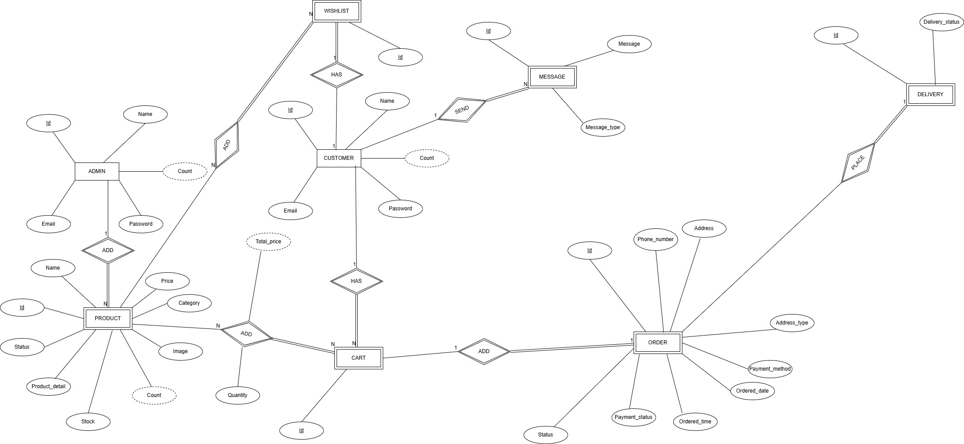
ER Diagram of Online Fashion Store Management System

Assumption

- Customer needs to log the system in order to place the order.
- DELIVERY is necessary to place a ORDER and a ORDER can have only one DELIVERY and vice versa.

Relations Explanation

ADMIN - PRODUCT Relation
- One ADMIN can add many PRODUCTs and a PRODUCT can have only one ADMIN.

CUSTOMER-CART Relation
- One CUSTOMER can have many CARTs and a CART can have only one CUSTOMER.

CUSTOMER-WISHLIST Relation
- One CUSTOMER can have one WISHLISTs and a WISHLIST can have only one CUSTOMER.

CUSTOMER-MESSAGE Relation
- One CUSTOMER can send many MESSAGEs and a MESSAGE can have only one CUSTOMER.

PRODUCT-CART Relation
- One CART can add many PRODUCTs and a PRODUCT can have many PRODUCTs.

PRODUCT- WISHLIST Relation
- One WISHLIST can add many PRODUCTs and a PRODUCT can have many WISHLISTs.

CART -ORDER Relation
  - CART is necessary to add a ORDER and a ORDER can have only one
CART and vice versa.

ORDER- DELIVERY Relation
- ORDER is necessary to place a DELIVERY and a DELIVERY can have only one ORDER and vice versa.

1

